Corey Hampton
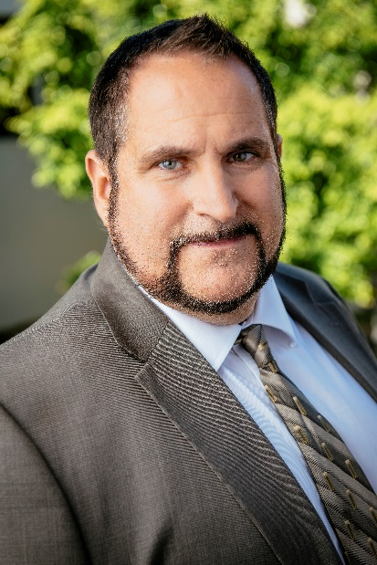
Property Supervisor

Professional Experience:
20012-Current

After graduating from The University of Wisconsin in 1996 and also serving In the US Army, I started teaching in Milwaukee public schools from 1993-1998 in a program called Troops to Teachers. After 5 years teaching, I decided change careers and to go back to school for a degree in Construction Management. I graduated in 2000 From the University of WI-Madison and obtained a degree in Construction Management and ROTC (Reserve Officer Training Corp.) and was commissioned in the US Army as a 2nd Lieutenant. I served in the reserves and was called to active duty in 2006 in which I did a tour in Iraq and Afghanistan. I left the military as a Captain for good in 2009. I was also working for a Real Estate Firm called Shore west Realtors located in Milwaukee, WI from 1998- 2006 and 2009-2012 after returning from active duty in the US Army.

In July of 2012, I decided to move to California after getting married to a woman from California. I took a job as the General Manager for a real estate company called SKB Properties in Los Angeles, CA.

In January 2021 I was then hired by Trumark as a Property Supervisor.

I was born in Chicago, IL.

I moved to Glendale in January 2021. I love attending Dodger Games and Los Angeles Rams games, concerts and traveling with the family in our boat in Marina Del Ray.

